Project Two - README

About the Project/Project Title
This application allows the user to utilize a locally stored database and apply pre-defined queries on that database. The users are granted full read/write permissions and can search for and view existing entries, filtered by rescue type candidacy or not.

Motivation
The motivation behind this project is simple. Grazioso Salvare wants to utilize animal shelter data to be able to search for specific candidates within the shelters in the hopes of rehoming them with suitable trainers for rescue training. Users are able to apply pre-determined filters on the database to see which dogs Grazioso Salvare believes are qualified for different types of rescue: Water, Mountain, and Disaster Rescue.

Getting Started
To get started, you will need to copy the databases, the python module that links to the database, and the script to run the application to your system.

Installation
The list of tools needed for installation is short. The first item to install will be Python 3.x, which is available at no cost to the user. The next item is MongoDB to manage your databases, which depending on size of organization can be either a paid service or free. Once those are installed, you will need to import the animal shelter database into MongoDB.
When the database has been imported, and users and permissions are set up, you then can run the python linking file and the python notebook in Jupyter Notebook. This will allow you to follow the screenshots in the Usage section.

Usage
When first running the software, the view will display the company logo as well as an identifier. It will also default to Water Rescue dogs.
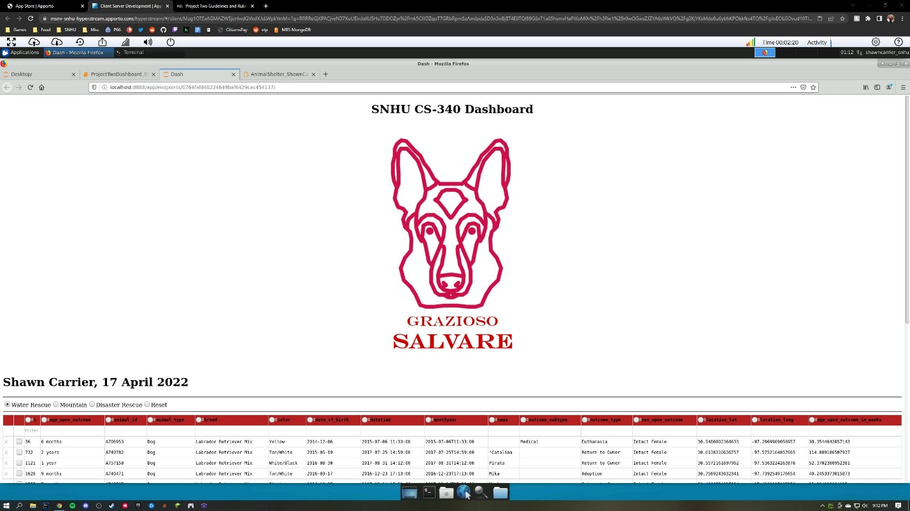

Looking at the default login screen, the pin we are given for the first dog in the list is blank due to the dog not having a name assigned to its database entry. In the next screenshot the list has been filtered to reverse the IDs and we are given a name for the first dog in the filtered list.
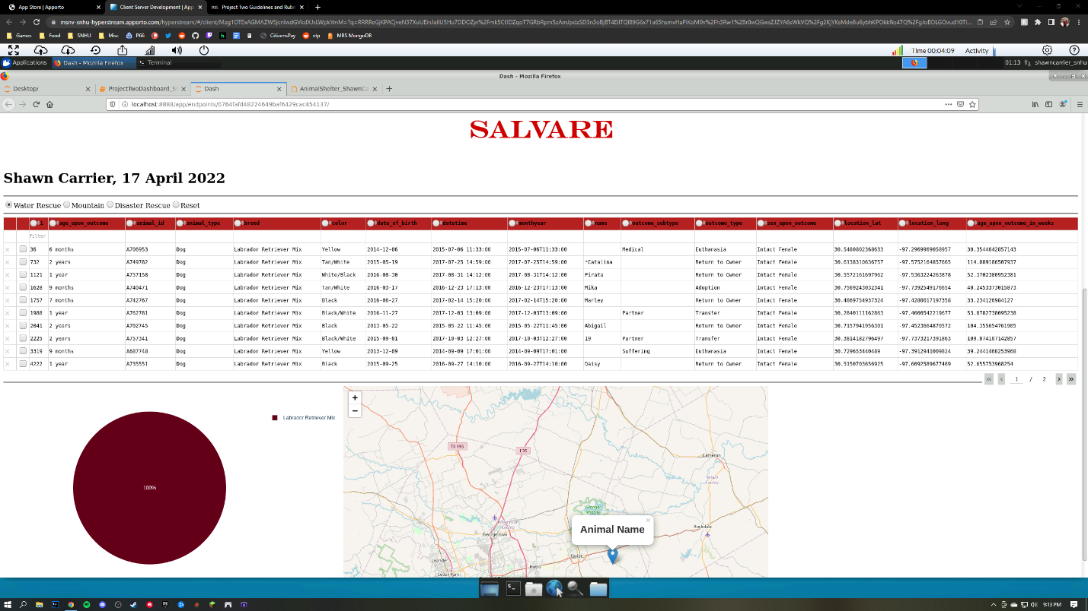
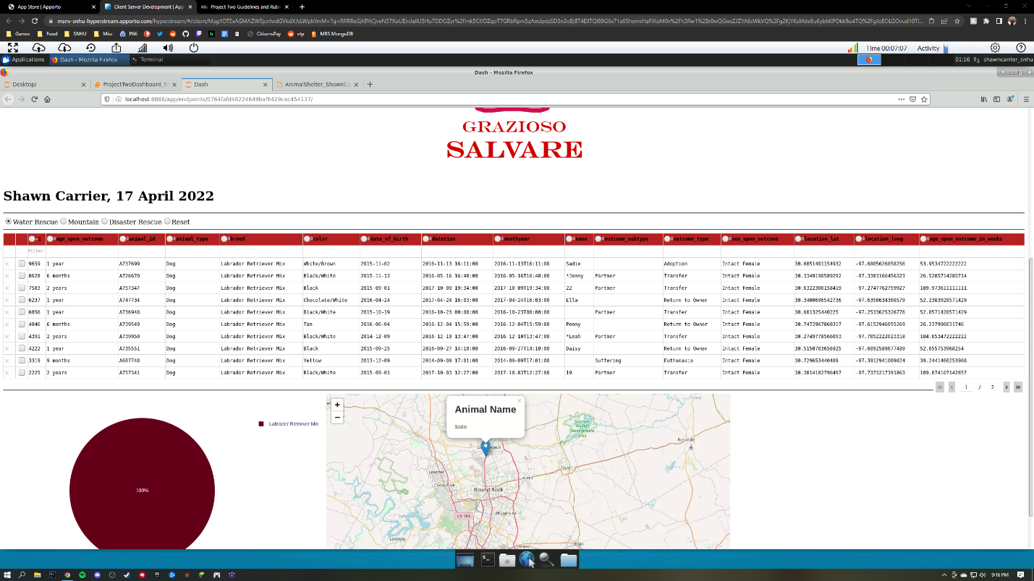

When we select the Mountain radio button, the database filters out dogs that are suited for our query for mountain rescue. As seen before and now, we have a chart that breaks down the breeds in the shelters that meet this query. 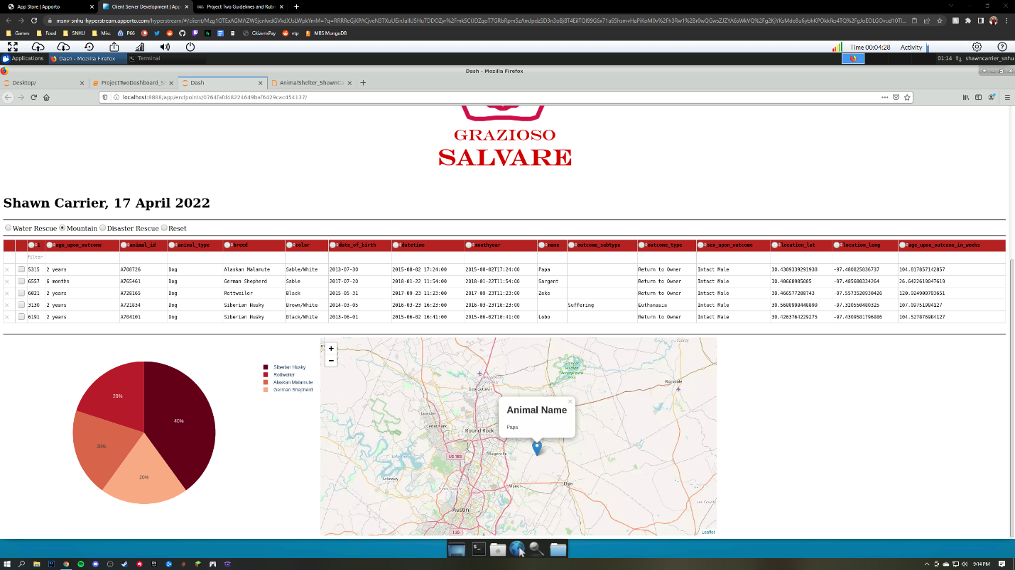

Similarly, we can see when the Disaster Rescue filter is applied all qualified dogs for disaster rescue are displayed.
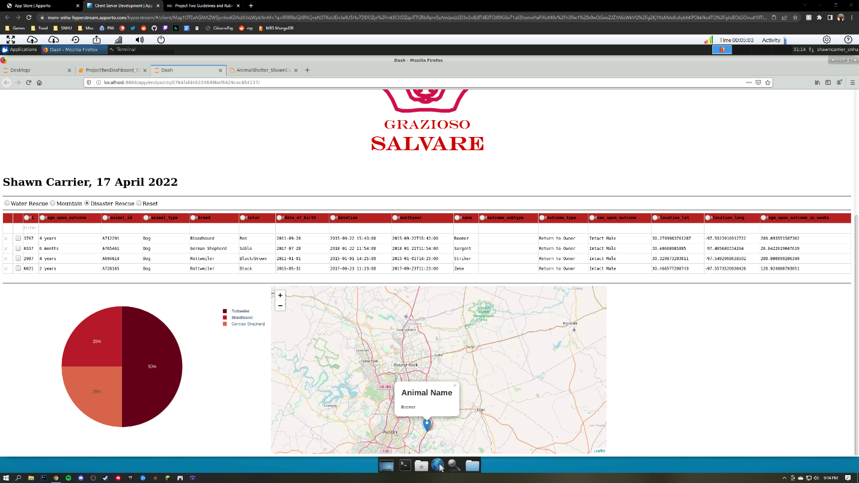

When the Reset radio button is selected, all filters and queries are removed showing us the entirety of animals in the current database, including cats and non-qualified rescue dogs.
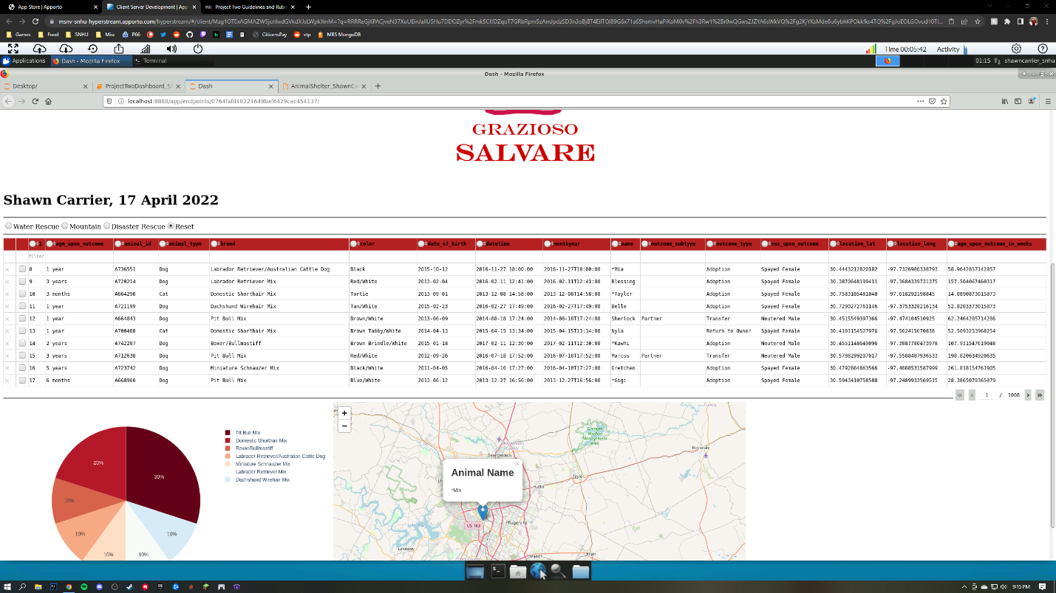

Contact
Shawn Carrier

